Commodore C64 PSU for the Kradex Z66 Case Rev. 1

Testing

# Test Setup

## Test Equipment

* Multimeter EEVblog 121GW (voltage, temperature)
* Multimeter Fluke 89 IV (current, temperature)
* Electronic Load East Tester ET5410
* Rigol MSO4024 oscilloscope
* Load Resistors (nominal 2.7Ω/25W, 2x4.7Ω/10W, 10Ω/25W, 18Ω/25W)
* C64 Power Tester (DIY, described in the module description)
* C64 S/N WG A 22471 (ASSY 250407), Ultimate II+, video equipment
* FLIR camera: Hti HT-19
* Thermometer: UNI-T UT320D

## Devices under Test (DUT)

1. Prototype Rev. 0 (AC/DC IRM-20-5, transformer VC 16/1/9)
2. Prototype Rev. 0 (AC/DC MPM-10-5, transformer TEZ10/D230/9V)
3. Prototype Rev. 1 (AC/DC IRM-20-5, transformer TEZ10/D230/9V)

Since the difference between Rev. 0 and Rev. 1 is only one spade connector for the illuminated power switch, it can be considered equal for testing.

# Test Execution

## 5VDC Load Test

The DC voltage under different load conditions were measured with the 121GW multimeter. The PSU was connected to the C64 Power Tester, the load was simulated with the electronic load. A good approximation of a “C64 load” on 5V is about 850mA. The different ASSY numbers have a different power dissipation. It is about 830mA for ASSY 250407 and 250425, while it is 730mA on ASSY 250469.

### IRM-20-5

|  |  |
| --- | --- |
| IOUT | UOUT |
| 0.00A | 5.03V |
| 0.85A | 4.88V |
| 1.50A | 4.79V |

### MPM-10-5

|  |  |
| --- | --- |
| IOUT | UOUT |
| 0.00A | 5.00V |
| 0.85A | 4.89V |
| 1.50A | 4.80V |

## 5VDC Ripple Test

The 5VDC were loaded with a 4.7Ω/10W load resistor. The electronic load was not used to prevent any influence of it on the measurement (Figure 1). An oscilloscope was connected to the 5V and set to AC mode, 5us/div.

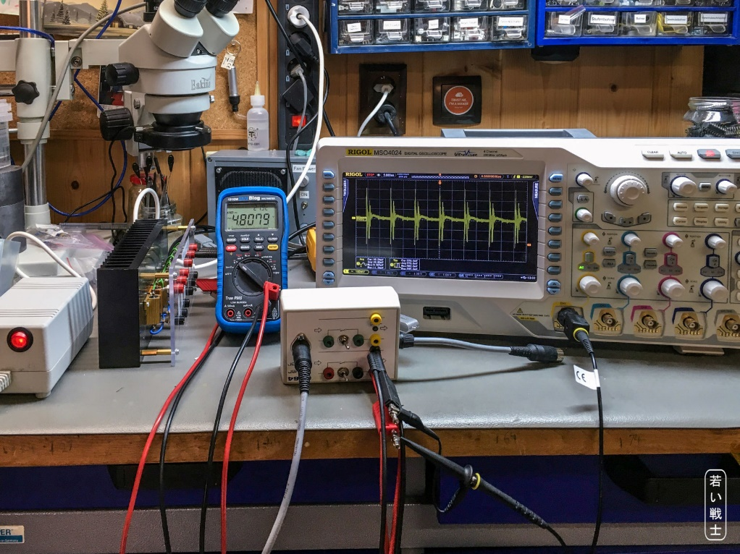

Figure : Setup for the ripple test

#### IRM-20-5

The vertical setting is 100mV. The ripple is 578.8mVpp and 60.52mVRMS.

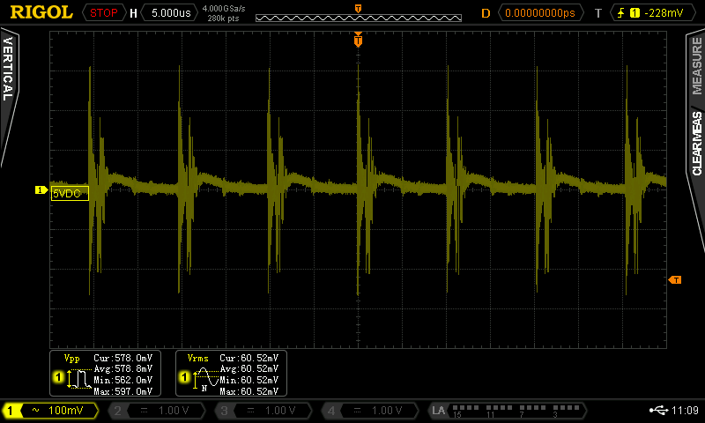

Figure 2: IRM-20-5 ripple

### MPM-10-5

The vertical setting is 20mV. The ripple is 85.31mVpp and 17.18mVRMS.

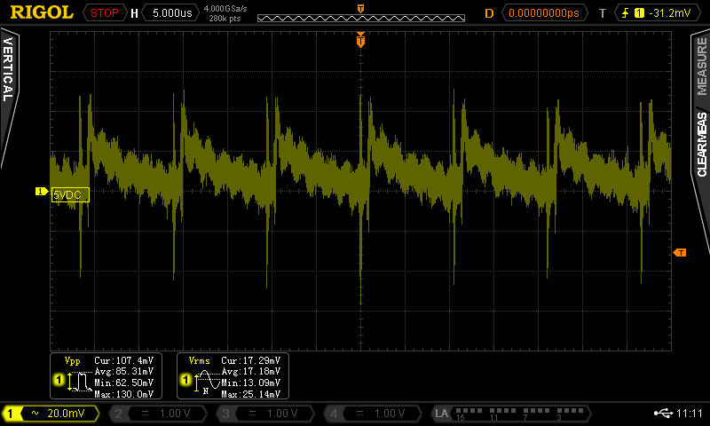

Figure 3: MPM-10-5 ripple

## **9VAC –** Transformer **Test**

### Procedure

1. Two different DUTs with both types or transformers were connected to the C64 Power Tester.
2. The 9VAC was loaded with different combinations of load resistors
3. For each combination, the output current and voltage were measured

### Block VC 16/1/9

Rated Power: 16VA

|  |  |  |
| --- | --- | --- |
| IOUT | UOUT | Diagram |
| 0.00A | 11.34V |  |
| 0.30A | 10.94V |
| 0.39A | 10.82V |
| 0.44A | 10.74V |
| 0.47A | 10.68V |
| 0.53A | 10.60V |
| 0.59A | 10.57V |
| 0.60A | 10.55V |
| 0.70A | 10.38V |
| 0.80A | 10.28V |
| 0.99A | 10.00V |
| 1.04A | 9.87V |
| 1.12A | 9.61V |

### BREVE TUFVASSONS TEZ10/D230/9V

Rated power: 10VA

|  |  |  |
| --- | --- | --- |
| IOUT | UOUT | Diagram |
| 0.00A | 11.73V |  |
| 0.30A | 11.01V |
| 0.39A | 10.81V |
| 0.47A | 10.60V |
| 0.51A | 10.51V |
| 0.58A | 10.34V |
| 0.59A | 10.30V |
| 0.68A | 10.06V |
| 0.77A | 9.83V |
| 0.93A | 9.41V |
| 0.98A | 9.31V |

## Thermal testing

The thermal testing was conducted with the electronic load set to 1.00A for the 5VDC and a load resistor of 10Ω/10W connected to the 9VAC. The 121GW and 89 IV multimeters were equipped with K-type thermo couples, which were first attached to the transformer and the AC/DC module with Kapton tape (Figure 4, Figure 5).

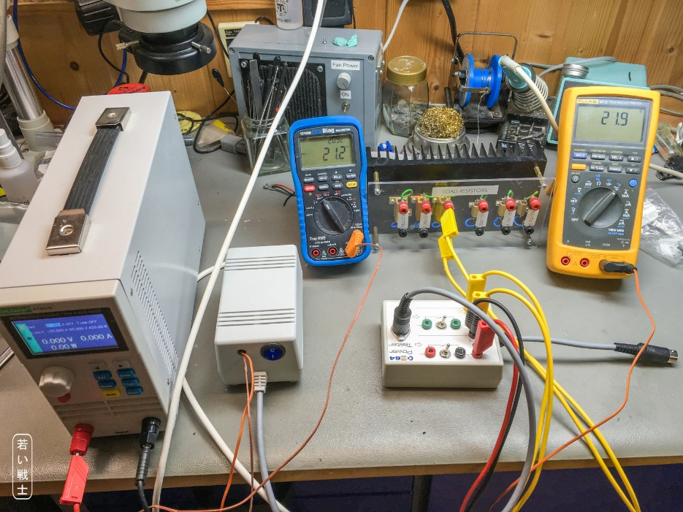

Figure 4: Setup for thermal testing

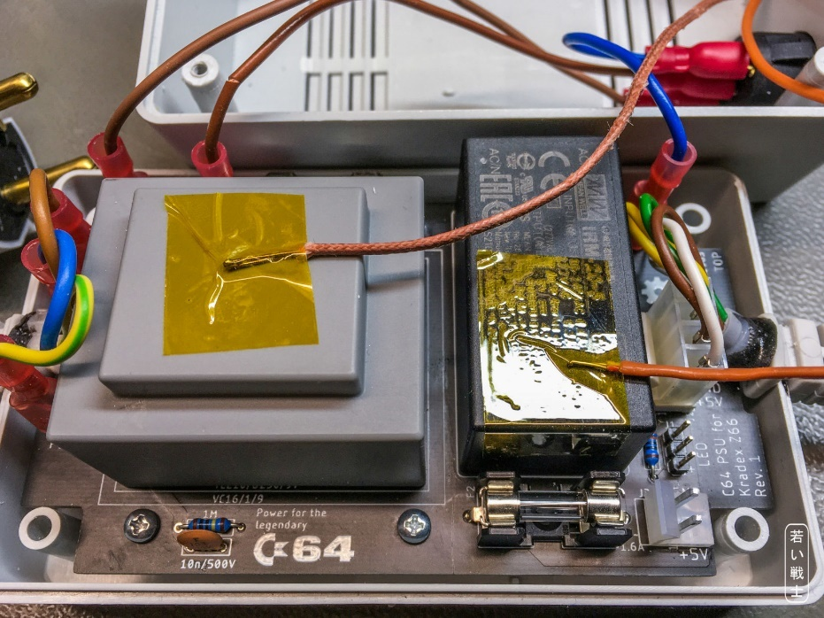

Figure 5: Position of the thermo couples for the 1st test run

The DUT was switched on and was running for a couple of hours until both temperatures settled to a maximum value. The transformer was the hottest of both components. In a second run, the 2nd thermo couple was placed on the case in the middle of the top shell (Figure 6).

With the TEZ10/D230/9V, a temperature of 65.6°C on the transformer surface and 48.6°C inside the case was finally reached (Figure 7). The ambient temperature was 22°C (initial reading from 121GW). The transformer is rated for a maximum ambient temperature of 60°C, the IRM-20-5 is rated 70°C, the MPM-10-5 is rated 85°C.

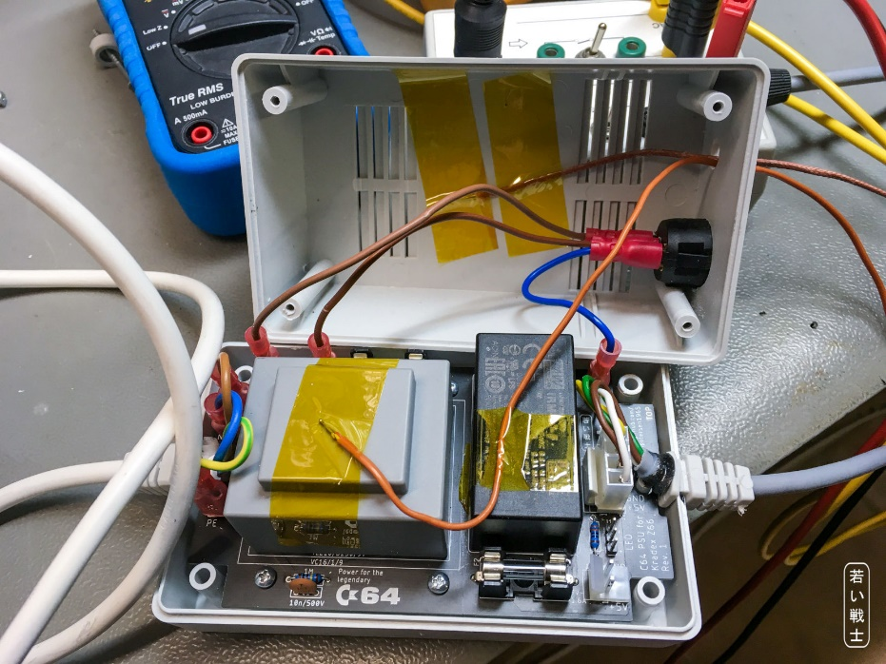

Figure 6: Thermo couple placement for the final run

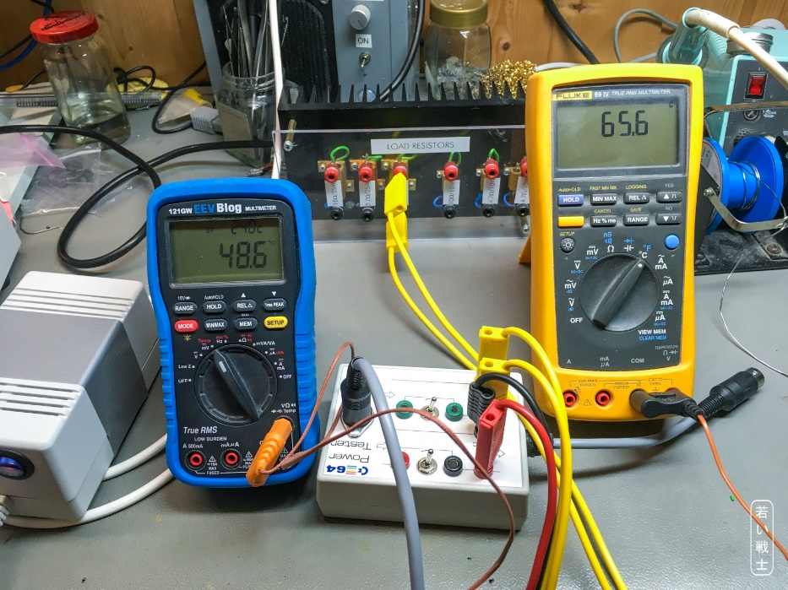

Figure 7: Final temperatures with the TEZ10/D230/9V transformer

The test was also executed with the Rev. 0 prototype that has the Block **VC 16/1/9** transformer. The ambient temperature was 22°C. After about 5 hours, the temperatures settled to 44.9°C inside the case and 52.2°C on the transformer. The transformer is rated for an ambient temperature of 40°C, which is exceeded by almost 5°C.

## Real Life Testing

Finally, the PSU (with the IRM-20-5) was tested with a real C64. ASSY 250407 was chosen due to the highest power consumption (827mA @ 5VDC, 778mA @ 9VAC) and the power hungry Ultimate II+ disk drive (and much more) emulator was connected. A C64 test software was loaded from the Ultimate II+ and executed (without a test harness) for 6 hours.

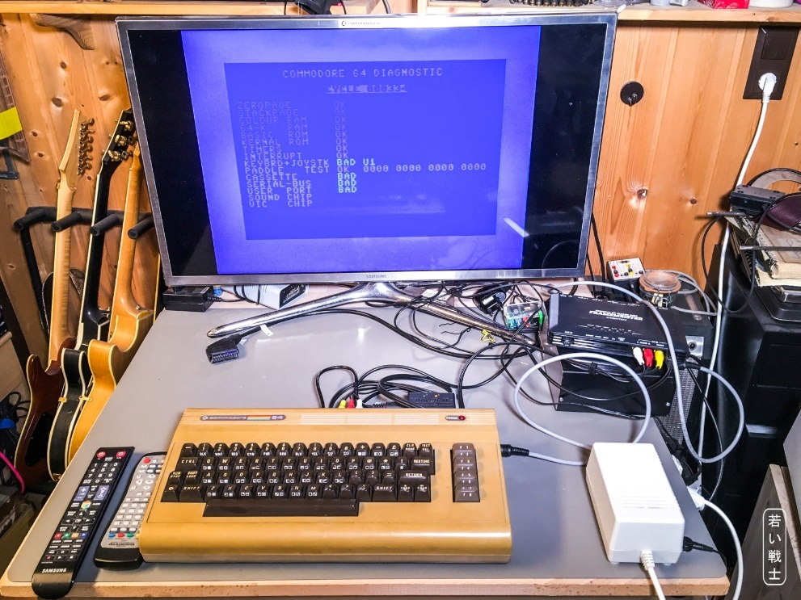

Figure 8: Setup of the real-life test

The software was running without any problems. It did not hook up.

Further, the Pi1541 (disk drive emulator) was powered by the PSU for another 3 hours. The C64 and the Pi1541 were active all the time, while demos have been played back. Again, no problems were found.

After this time had elapsed, the temperatures were measured with a surface probe.

|  |  |
| --- | --- |
| Locaction | Temperature |
| Top of case | 33°C |
| Top of transformer | 50°C |
| Top of AC/DC module | 56°C |

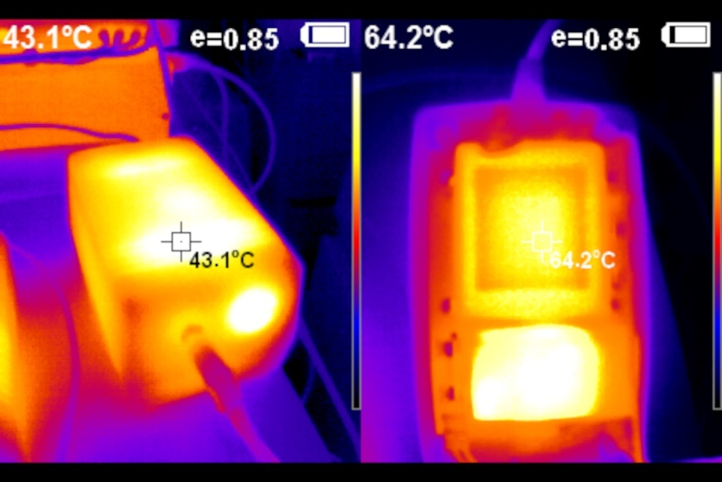

Figure 9: FLIR images of the outside and inside of the PSU

Note: the temperature measurement requires setting the proper emissivity (e) for each material, so the displayed temperatures (Figure 9) are not accurate.

# Conclusion

## AC/DC Modules

Both modules work. The IRM-20-5 has a higher maximum output current (4A) and a higher ripple (which is not considered critical). The MPM-10-5 is more expensive, has only 2A output current and a lower ripple. It is approved for medical equipment, which explains the higher price.

## Transformers

Both transformers work. At the current consumption of about 0.75A (ASSY 250405 and 250425), the output voltage of the 16VA transformer is about 0.5V higher than the one of the 10VA transformer. This will lead to 0.4W more power dissipation in the linear voltage regulators and an increased temperature. It is not critical for most C64s, except some of the early ASSY320298, which do not have a heat sink installed on the 7805 5V lineal regulator.

The **VC 16/1/9** (16VA) has a much lower rating for the maximum ambient temperature (40°C) than the 10VA transformer TEZ10/D230/9V (60°C). The current drawn while the thermal testing is higher than the current drawn by a C64. The 16VA variant stays cooler, but still the maximum temperature is exceeded by 5°C. It is probably not critical, but definitely **not recommended**.

Thus, the **TEZ10/D230/9V is the preferred type**.

## Final verdict

Both tested revisions are **fully functional**. The VC 16/1/9 transformer is not recommended.